# Lab: Bootstrap Plugins

Problems for in-class exercises for the ["JavaScript For Front-End Course @ SoftUni"](https://softuni.bg/trainings/2032/javascript-for-front-end-july-2018#lesson-8965).

You are given the **text**, **screenshots**, and **GIFs** for the problems, as **resources**.

## Collapse

Create a Web Page like the following:

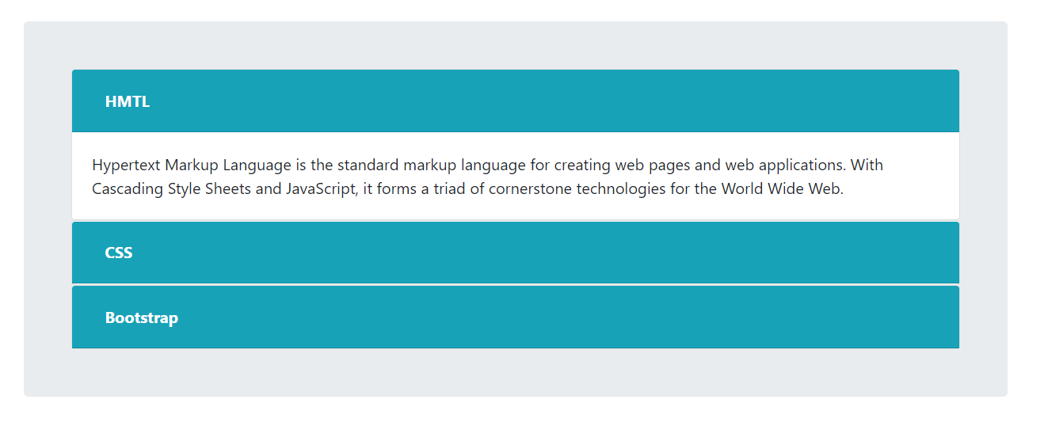

The links should **contain** text **inside** them. The text should **toggle** **hide** and **show** upon **click**.

### Constraints

* Take a look at [Bootstrap documentation](https://getbootstrap.com/docs/4.1/components/collapse/).
* Do **NOT** use any custom **CSS**.

## Social-Buttons

Create a Web Page like the following using **only** **Bootstrap** and [**Social** **Buttons**](https://lipis.github.io/bootstrap-social/) Plugin:

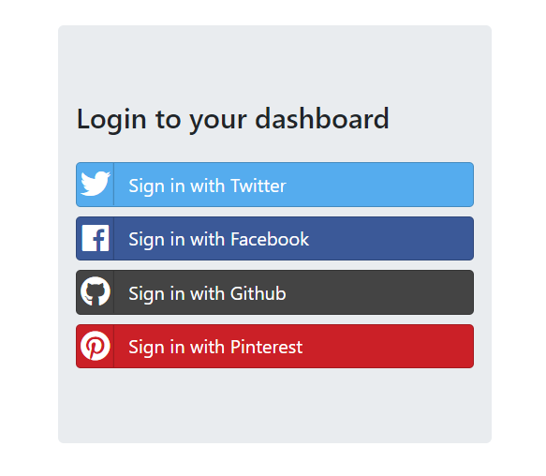

### Constraints

* You should be able to open every **hyperlink** in a **new** **tab** like the following screenshot:

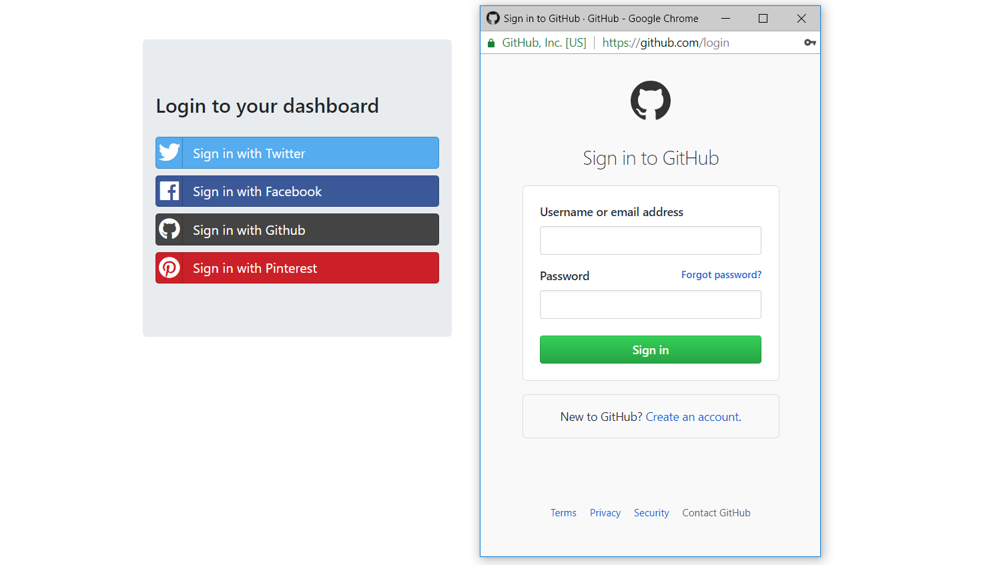

### Hints

* If you need help with the **new window functionality**, check [here](https://stackoverflow.com/questions/31539415/html-how-to-open-this-url-in-new-window).

## SweetAlert

Create a Web Page like the following using **Bootstrap** for **design**, [**SweetAlert**](https://lipis.github.io/bootstrap-sweetalert/) **Plugin** for **notifications** and somecustom **JS** for **functionality**:

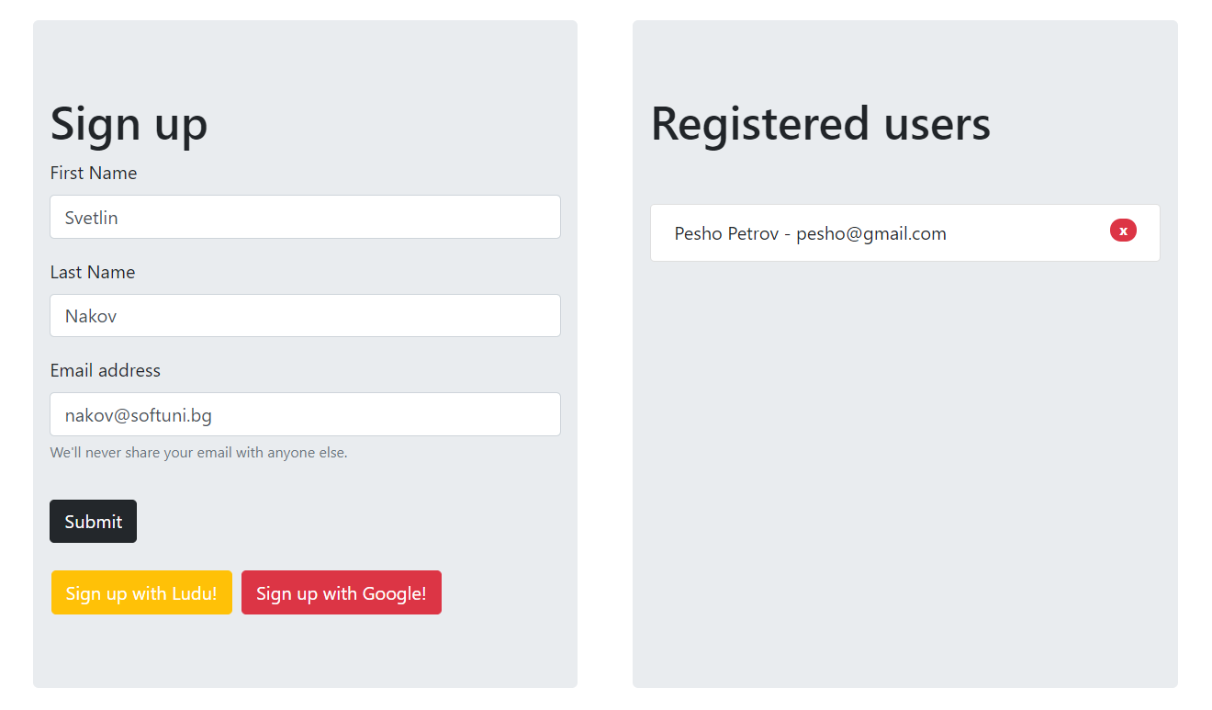

### Constraints

* You should implement the following **notifications** using the **plugin:**

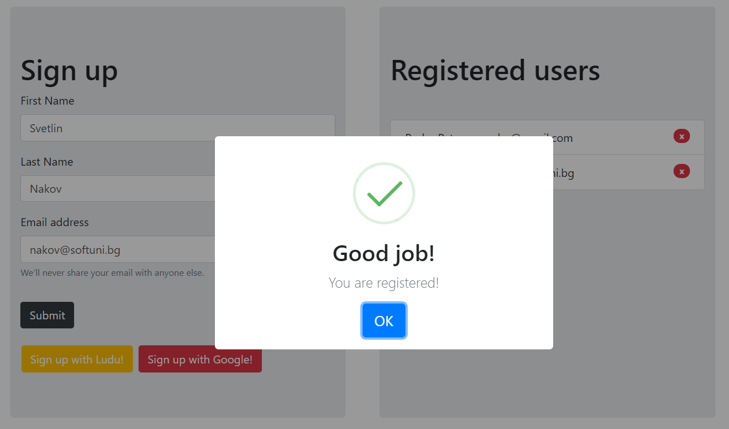

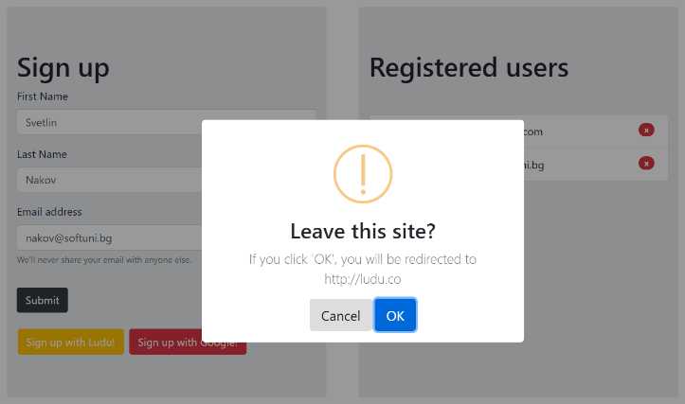 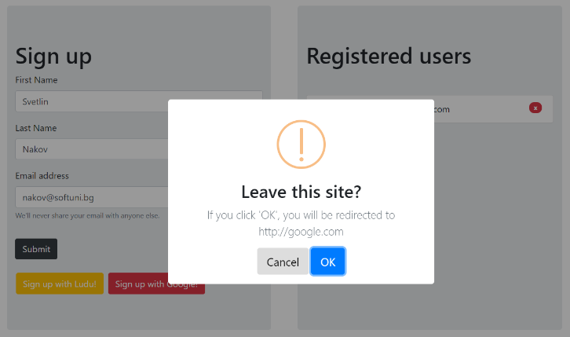

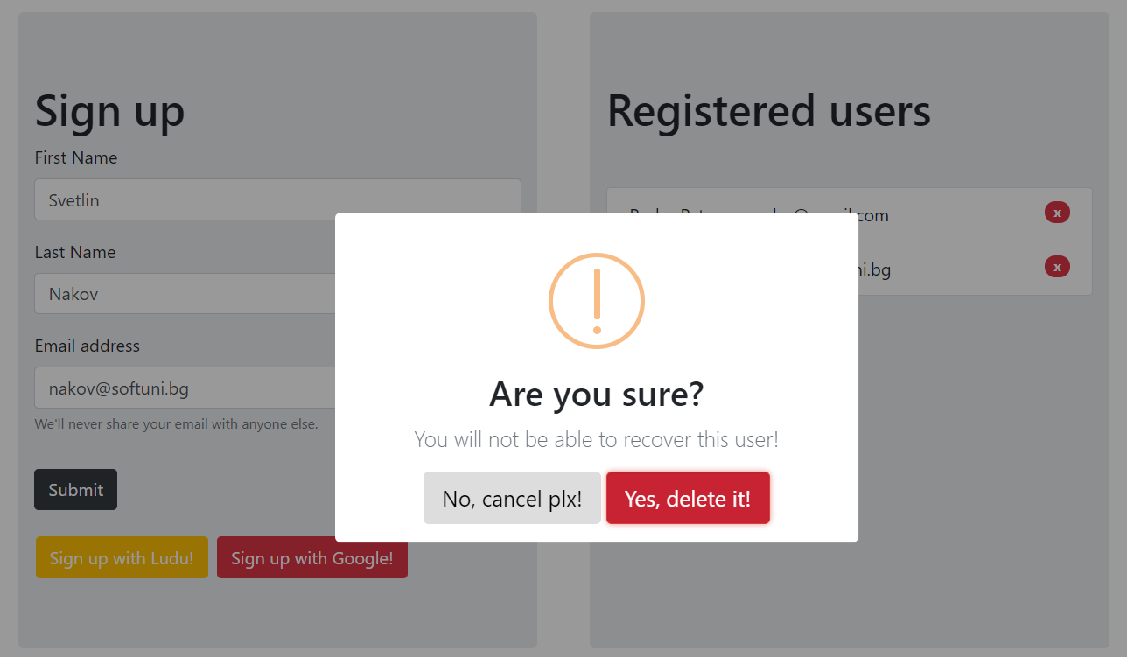

## Dropify

Create a Web Page like the following using **only** **Bootstrap** and [**Dropify**](http://jeremyfagis.github.io/dropify/) Plugin:



